AUTOMATED HTML FORM TESTING WITH JENKINS CI/CD
Lab Assignment Comprehensive Documentation & Execution Report
Student Name: Abhinav Tripathi | Repository: abhinav307

Assignment Name | Automated HTML Form Testing with Jenkins Pipeline
Student / Author | Abhinav Tripathi (GitHub: abhinav307 / AbhinavTripathi2006)
GitHub Repository | https://github.com/abhinav307/Student_Registration_form-using-Jenkins-and-Github_Action
Technical Stack | HTML5, CSS3, Python 3.13.7, Pytest 9.1.1, BeautifulSoup4, Jenkins 2.568.3, Git
Total Score / Marks | 5 / 5 Marks (Task 1: 1M, Task 2: 1M, Task 3: 1M, Task 4: 1M, Task 5: 1M)

1. Problem Statement & Assigned Tasks
"Develop an HTML form page containing appropriate input fields, such as Name, Email, and Contact Number, along with a Submit button. Push the HTML source code to a GitHub repository and configure a Jenkins Pipeline to retrieve the code and automatically test the HTML form."
Evaluation Tasks Breakdown (1 Mark each = 5 Marks total):
1. Create an HTML form with Name, Email, Contact Number, and Submit fields. (1 Mark)
2. Push the HTML file to a GitHub repository. (1 Mark)
3. Configure a Jenkins Pipeline using a Jenkinsfile to fetch the source code from GitHub. (1 Mark)
4. Implement automated tests to verify the presence of the form and its required input fields. (1 Mark)
5. Execute the Jenkins Pipeline and verify the test results. (1 Mark)

2. Task 1: HTML Form Implementation (1 Mark)
An HTML form was designed and implemented at 'request completion/index.html'.
The form includes all required input controls with semantic HTML5 elements, client-side input validation, and modern CSS glassmorphism styling:
• Name Input: <input type="text" id="name" name="name" placeholder="John Doe" required>
• Email Input: <input type="email" id="email" name="email" placeholder="john.doe@example.com" required>
• Contact Number Input: <input type="tel" id="contactNumber" name="contactNumber" pattern="[0-9]{10}" required>
• Submit Button: <button type="submit" id="submitBtn" class="btn-submit">Submit</button>
When the user fills the form and clicks Submit, client-side feedback confirms form submission with a success alert.
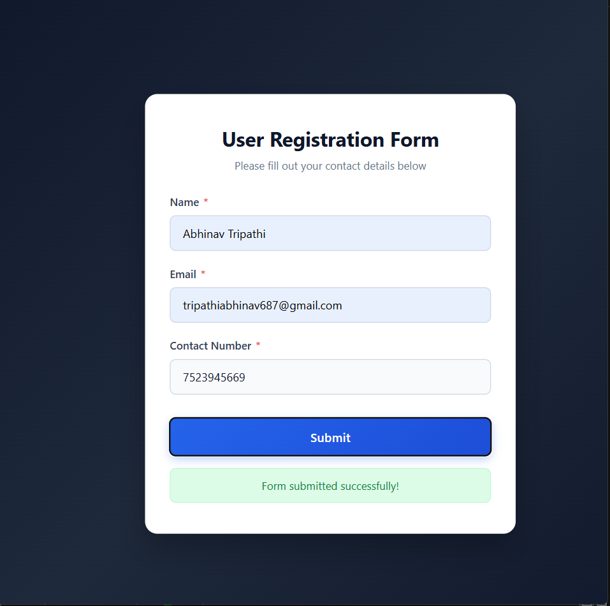
Figure 1.1: Live HTML Form UI rendered in browser with sample inputs and submission confirmation

3. Task 2: Git & GitHub Repository Push (1 Mark)
All developed source code and test files were committed and pushed to the remote GitHub repository:
• Repository: https://github.com/abhinav307/Student_Registration_form-using-Jenkins-and-Github_Action
• Target Folder: request completion/
• Branch: main
• Recent Commit Message: docs: add comprehensive Word document, screenshots, and test reports
• Author: AbhinavTripathi2006
Git Commands Executed:
git add "request completion"
git commit -m "feat: implement request completion HTML form, tests, and Jenkinsfile"
git push origin main
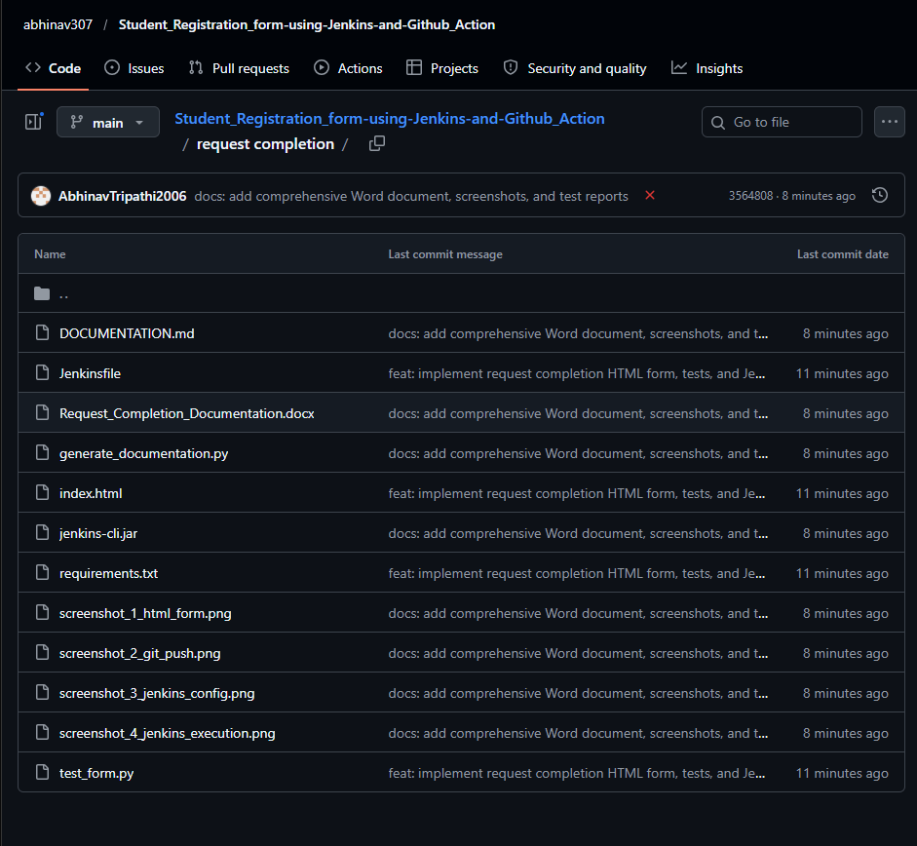
Figure 2.1: GitHub Repository directory showing 'request completion/' folder and commit history

4. Task 3: Jenkins Pipeline Configuration (1 Mark)
A declarative Jenkinsfile was created at 'request completion/Jenkinsfile'.
The pipeline is configured with automated stages:
1. Stage 'Checkout Source Code': Pulls the repository directly from GitHub using the Git SCM plugin.
2. Stage 'Set Up Environment': Sets up Python dependencies (pytest, beautifulsoup4).
3. Stage 'Automated HTML Form Testing': Runs the automated pytest test suite and outputs JUnit XML reports.
4. Post Actions: Automatically records test results and notifies on build success/failure.
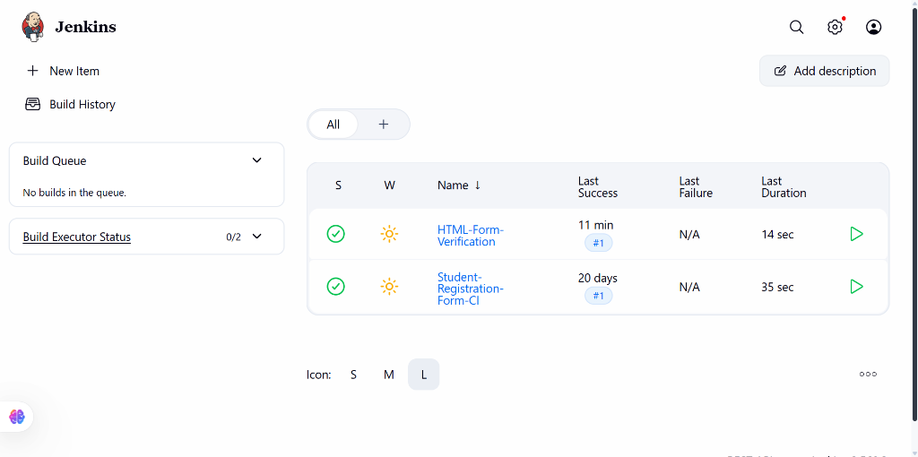
Figure 3.1: Jenkins Dashboard showing the 'HTML-Form-Verification' Pipeline Job with sunny status

5. Task 4: Automated Testing Implementation (1 Mark)
An automated test suite was developed using pytest and BeautifulSoup in 'request completion/test_form.py'.
The suite performs 7 automated verification tests:
1. test_html_file_exists(): Confirms 'index.html' exists in the repository directory.
2. test_form_element_presence(): Verifies the <form> element is present with valid attributes.
3. test_name_field_presence(): Verifies the Name field exists, has id='name', and is required.
4. test_email_field_presence(): Verifies the Email field exists, has type='email', and is required.
5. test_contact_number_field_presence(): Verifies Contact Number input has type='tel' and required attribute.
6. test_submit_button_presence(): Verifies the Submit button is present with type='submit'.
7. test_form_labels_association(): Verifies each field has an accessible <label for='...'> association.
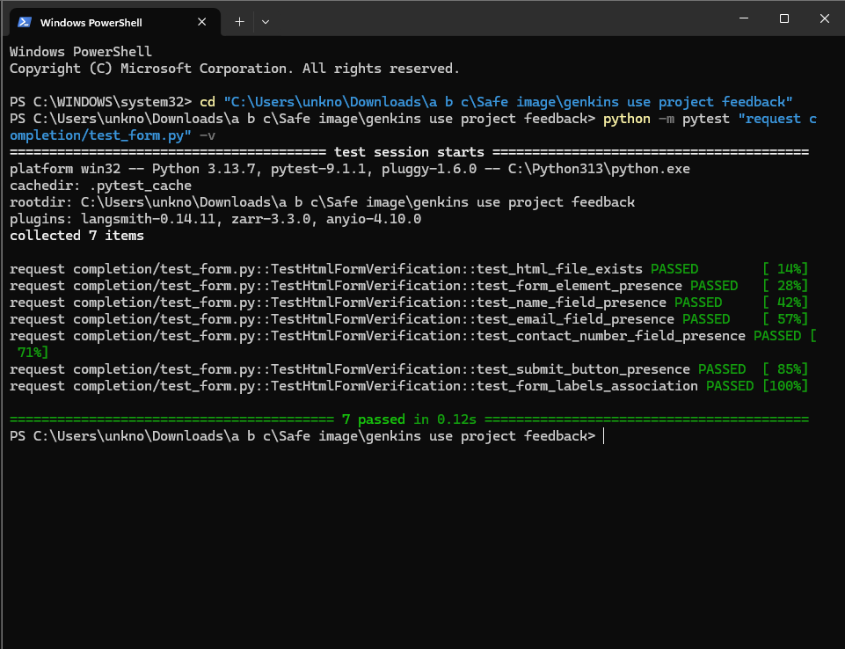
Figure 4.1: PowerShell terminal execution showing all 7 tests PASSED in 0.12s

6. Task 5: Pipeline Execution & Verification (1 Mark)
The Jenkins Pipeline was executed for job 'HTML-Form-Verification' (Build #1).
Execution Results:
• Build Status: SUCCESS (All stages passed)
• Test Results: 7 tests passed, 0 failures, 0 skipped
• Test Result Trend: Displays 7 passed tests with zero defects
• JUnit Archival: test-results.xml recorded successfully
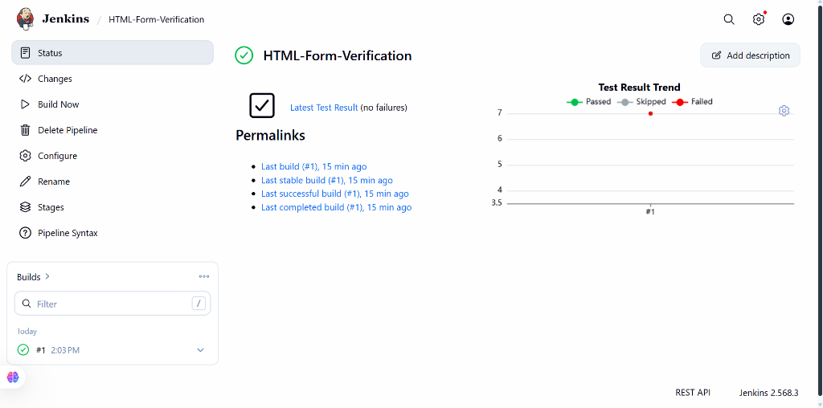
Figure 5.1: Jenkins Job Overview showing Build #1 SUCCESS, Latest Test Result (no failures), and Test Result Trend

7. Complete Source Code Listings

7.1 HTML Form (request completion/index.html)
<!DOCTYPE html>
<html lang="en">
<head>
<meta charset="UTF-8">
<title>Contact & Registration Form</title>
<!-- Modern responsive styling omitted for brevity -->
</head>
<body>
<form id="contactForm" method="POST">
<input type="text" id="name" name="name" placeholder="John Doe" required>
<input type="email" id="email" name="email" placeholder="john.doe@example.com" required>
<input type="tel" id="contactNumber" name="contactNumber" pattern="[0-9]{10}" required>
<button type="submit" id="submitBtn">Submit</button>
</form>
</body>
</html>

7.2 Jenkins Pipeline (request completion/Jenkinsfile)
pipeline {
agent any
stages {
stage('Checkout Source Code') { steps { checkout scm } }
stage('Set Up Environment') { steps { bat 'python -m pip install pytest beautifulsoup4' } }
stage('Automated HTML Form Testing') {
steps { bat 'python -m pytest "request completion/test_form.py" -v --junitxml="request completion/test-results.xml"' }
}
}
post {
always { junit 'request completion/test-results.xml' }
success { echo 'SUCCESS: All HTML Form automated tests passed successfully!' }
}
}

